#### **A**

#### **Project Report**

#### **On**

**“****ONLINE HOSPITAL MANAGEMENT SYSTEM”**

### Submitted By

**Mr. Deshmukh Omkar A. Mr. Gopale Tejas J.**

**Mr. Dhumal Gaurav A.**

**Mr. Deokar Rahul P.**

**Mr. Aher Atharva S.**

**Guided By**

**MR. MORE S.**

### In partial fulfilment for award of the degree

### BATCHLOR OF COMPUTER SCIENCE



**LOKNETE DR. BALASAHEB VIKHE PATIL (PADMABHUSHAN AWARDEE)**

**PRAVARA RURAL EDUCATION SOCIETY’S**

**PADMASHRI VIKHE PATIL COLLEGE OF ARTS SCIENCE AND COMMERCE, PRAVARANAGAR**

**TAL-RAHATA, DIST-AHMEDNAGAR Pin-413713**

**Year: 2021-22**

**CERTIFICATE**

#### This is to certify that the work embodied in the project

**“ONLINE HOSPITAL MANAGEMENT SYSTEM”** is the original work done by **Mr. Omkar Anil Deshmukh, Mr. Rahul Prakash Deokar, Mr. Tejas Jalindar Gopale,**

**Mr. Atharva Sudhakar Aher, Mr. Gaurav Annasaheb Dhumal.** for the degree of Batchelor in Computer Science of Savitribai Phule Pune University, Pune in “JAVA, JAVASCRIPT,MYSQL” under my personal guidance and has completed to my entire satisfaction.

**Project Guide HOD**

**Internal Examiner External Examiner**

|  |  |  |
| --- | --- | --- |
| **Sr. No.** | **Content** | **Page No.** |
| **1** | **Introduction** | **5** |
| 1.2 | Existing System and Need for System | 6 |
| 1.3 | System Requirement | 7 |
| 1.4 | Scope of Work | 8 |
| 1.5 | Objective | 9 |
| 1.6 | Limitation | 11 |
| **2** | **Propose System** | **12** |
| 2.1 | Proposed System | 12 |
| 2.2 | User Requirement | 13 |
| 2.3 | Feasibility Study | 15 |
| **3** | **System Analysis and System Design** | **18** |
| 3.1 | ER Diagram | 18 |
| 3.2 | Class Diagram | 19 |
| 3.3 | Use-case Diagram | 20 |
| 3.4 | Activity Diagram | 21 |
| 3.5 | Sequence Diagram | 22 |
| 3.6 | State chart Diagram | 23 |
| 3.7 | Collabration Diagram | 24 |
| 3.8 | Component Diagram | 25 |
| 3.9 | Deployment Diagram | 26 |



**INDEX**

|  |  |  |
| --- | --- | --- |
| **4** | **Data Dictionary** | **27** |
| **5** | **Screen Shots** | **31** |
| **6** | **Proposed System Enhancement** | **41** |
| **7** | **Conclusion** | **42** |
| **8** | **Bibliography** | **43** |



**Project Introduction**

##### Project Introduction

Online hospital management system: A unique hospital management system for both patients and hospital staffs (Doctors, Management). The primary target of this design is to make hospital experience better than we currently have. Hospital is a place where no one willingly wants to visit but there are times when we need to. The old system of hospitals are not very user friendly. The first big stem is waiting in the queue for long hours. There are lots of other problems that makes your hospital experience bad. Our main focus is to make peoples life easier in the hour of need. We are working to design such a system that will reduce a lot of paperwork and save peoples time.

Online Hospital Management System is powerful, flexible, and easy to use and is designed and developed to deliver real conceivable benefits to hospitals.

Hospital Management System is designed for multispeciality hospitals, to cover a wide range of hospital administration and management processes. It is an integrated end-to-end Hospital Management System that provides relevant information across the hospital to support effective decision making for patient care, hospital administration and critical financial accounting, in a seamless flow. Hospital Management System is a software product suite designed to improve the quality and management of hospital management in the areas of clinical process analysis and activity- based costing. Hospital Management System enables you to develop your organization and improve its effectiveness and quality of work. Managing the key processes efficiently is critical to the success of the hospital helps you manage your processes



**Existing System**

##### EXISTING SYSTEM AND NEED FOR SYSTEM

Existing System

Existing system is patient do not take the appointments of particular doctor. Facilities in the hospital are not known to the users. Existing provide information about hospital are only available within the hospital. Not solved any problems.

Need of System:

System can be used by simple users who are take online appointments of particular doctor. Scope of project is that it gives only some specified information about hospital. This website can be installed on windows 8,10 based operating system.

The proposed system is having following objectives.

* + - User friendliness is provided in the application with various controls.
    - The system makes the overall project management much easier and flexible.
    - It can be accessed over the internet.
    - Vast amount of data can be stored.
    - There is no risk of data mismanagement at any level while the project development is under process.
    - Relationship between the administrator, owner/developer and subcontractor can be maintained very easily.
    - It provides high level of security using different protocols like https etc.
    - The Online Hospital Management System consists of 3 users or modules, they are:
    - Administrator
    - Doctor
    - User or Patient



**System Requirement**

1.3 SYSTEM REQUIREMENT

# HARDWARE REQUIREMENT

* + i3 processor.
  + 2GB RAM
  + 500 GB Hard-Disk.

# SOFTWARE REQUIREMENT

* + Windows 8, Windows 10
  + Front End – HTML, CSS, Bootstrap, JavaScript, JSP.
  + Back End – Java, MySQL
  + Server – Apache Server 9.0.62
  + Design Tool – Eclipse
  + Documentation Tools – Microsoft Word.

**Web Requirements**

* + - Bandwidth – 1mbps(minimum)
    - Internet – 512 kbps(minimum)
    - Internet Explorer 8.0 or any browser



**Scope**

##### 1.4 SCOPE Of WORK

1)Information about Patients is done by just writing the Patients name, age and gender. Whenever the Patient comes up his information is stored freshly.

2) Bills are generated by recording price for each facility provided to Patient on a separate sheet and at last they all are summed up.

3)Diagnosis information to patients is generally recorded on the document, which contains Patient information. It is destroyed after some time period to decrease the paper load in the office.

4)Immunization records of children are maintained in pre-formatted sheets, which are kept in a file.

5)Information about various diseases is not kept as any document. Doctors themselves do this job by remembering various medicines. All this work is done manually by the receptionist and other operational staff and lot of papers are needed to be handled and taken care of. Doctors have to remember various

medicines available for diagnosis and sometimes miss better alternatives as they can’t remember them at that time



**Objective**

##### 1.5 OBJECTIVE

Online Hospital Management System automates and manages the working of hospitals. This is faster and more impressive than the traditional hospital system. The whole project is divided into different modules. The proposed system not only overcomes the loopholes in the existing system but also provides additional features, which will help in better management and also make the work of users easier. The specific objectives of the research are:

* To maintain the record of indoor and outdoor patients

.•To computerize the records of employees working in the hospital, including their financial aspects

.•Automation of billing of patients.

* Management of Hospital Stock Inventory.

The patient record touches, in some way, virtually everyone associated with providing, receiving or reimbursing health care services. This wide range of applications and use has led to efforts to automate the collection, storage and management of the data that constitute these records. But in spite of more than 30 years of exploratory work and millions of dollars in research and implementation of computer systems in health care provider institutions, patient records today are still predominantly paper records. This evident lack of diffusion of information management technologies in the health care sector has limited the tools available for effective decision-making. Given the importance of patient data to the activities of all portions of the health care spectrum, an effort was made to improve patient records, acting in response to expanding demands for information and for increased functional capacity of patient record systems, as well as the considerable recent technological advances that bring the benefits of computer-based patient records within reach. A patient's medical record has always been a dispersed entity. It can be defined as the accumulation of medical information concerning the patient. Ideally, this information is bundled in a single folder with the patient's identification data on the cover. Much of the information in the records is obsolete, redundant, duplicated or indecipherable to the extent that it does not benefit the patient at the point of care. Ownership of the data is also a limiting issue. Many hospitals consider the records in their systems to be their property, whereas many patients argue that their medical information is their own. Consequently, a distinction is made between ownership of the physical record and the right to access (or duplicate) data that are stored in it. It is typically agreed that patients have the right to be informed of the general content of their medical record and that patients' care providers must be allowed access to any information that is relevant to a patient's treatment. They said that using the Internet to transmit medical information could allow providers, access to medical information at the point of care, but it might violate patient confidentiality. Obstacles that have prevented such implementation include patient and provider identification, security requirements, content issues, format and language. A patient controlled, “granularly secured” and cross sectional medical record that is accessible via the World Wide Web may be simple enough to implement and practical enough to show benefit. Electronic medical record systems improve the quality of patient care and decrease medical errors, but their financial effects have not been as well documented. If we estimate the net financial benefit and cost of implementing electronic medical record systems in primary care and perform a cost-benefit study to analyze the financial effects of electronic medical record systems in ambulatory primary care settings from the perspective of the health care organization, benefits accrue primarily from savings in drug expenditures, improved utilization of radiology tests, better capture of Design and Development of Online Hospital Management Information System81charges and decreased billing errors. Implementation of an electronic medical record system in primary care can result in a positive financial return on investment to the health care organization and the magnitude of the return is sensitive to several key factors.

Automation results in an improvement in response time and greater efficiency in diagnostic procedures. Electronic health records (EHRs) have a great impact on documentation time of physicians and nurses. The use of bedside terminals and central station desktops caused reduction in documentation time



**Limitations**

##### 1.6 LIMITATIONS

**1**) Only appointments are taken in that website.

1. All information about the hospital are not mention in that website.
2. The size of the database increases day-by-day, increasing the load on the database back up and data maintenance activity.

**4)**Training for simple computer operations is necessary for the users working on the system.

1. Excel export has not been developed for Hospital, Doctors due to some criticality.
2. The transaction are executed in off-line mode, hence on-line data for Patient, Employee capture and modification is not possible.



**PROPOSED SYSTEM**

##### 2.1PROOPOSED SYSTEM

Online hospital Management System is a digital application which easily visit online. This website is simple to handle as well as use to noncomputer user also. We can also easily find the required information about Ghati Hospital. We can easily find specialty doctors and take appointment of that doctor.

This software automates and manages the working of hospitals. The database system keeps track of data required for various departments in a hospital. The whole project is divided into following modules:

* + - **Patient Details (IPD/OPD)** :This module keeps record of the indoor patients admitted, new outdoor patients,old outdoor patients revisiting the hospital for check- up, patients discharged, employees working in the hospital, details of the rooms issued to the patients, charges of various rooms, room transfers of the patients within the hospital, receipts for advance and bill payments, etc

**.•Billing** :This module is used for managing the billing of patients including all kinds of charges such as room charges, doctor charges and other miscellaneous charges deducting the net advance paid, if any and discount provided,if any.

* + - **Login** :This module deals with the security matters, user logons and authentications. It is used to create new users, who can login to the software of hospital and change password, if a user finds some security problems. Proper authorization will be done to take care of who is accessing the database – Administrator, CMO, doctor, operator or patient.
* **Reduction of Paper Work**: No need of voluminous files

• **Speed**: The machine can retrieve and modify data far faster than a human can.

* **Redundancy**: Redundancy of data entry can be eradicated.
* **Cost Saving**: Money spent on papers and files can be saved.
* Easy and Durable Storage
* Ease in the process of handling accounts like bill payments and receipts
* Proper Authorization and Security
* Online Access



**User Requirements**

##### 2.2 USER REQUIREMENTS

The system is developed taking into the various requirements of the Customer. They can be listed as below:-

1. peoples known the information about hospital
2. peoples have some problems related to hospital facilities.
3. These all solved by Mhaske Hospital System
4. Patients are take appointment of specialist doctor.

##### Functional requirements

A user interacts with the system. It involves registration for Admin,Patient and Doctor as well as sending them questions. It also includes functions for the Online Hospital System to register and approve registered appointment.

##### Non-functional requirements

**Usability :** Our system is reusability system since a segment of source code that can be used again to add new functionalities with slight modification.

**Portability** : The Online result analysis shall run in any platform environments because it is platform independent and the MYSQL

**Availability** : However can open site anytime to access other information for Customer. Customer can register anytime. This system must run on multiple operating systems and also support windows operating system

**Robustness :** Product is robust. Because, security has become more robust in java. In addition to the role based security in java comes with a new security model, codes access security. This security controls on what the code can access.



**Feasibility Study**

##### Feasibility Study

The above specified software is feasible in all manners i.e. Technically operationally and economically.

1. No training is required
2. No extra investment
3. No extra hardware and hardware installation
4. No running expenses
5. (O.S. is already available)
6. The user of this system is system administrator so very less training is required (Few minutes)

As per my convenience, we decide to develop the computerized system, & start work on it, then our first work is to checked whether the propose system is feasible in the point of view of operational, technical and economical or not? Depending on the results of the initial investigation the survey is now expanded to a more detailed feasibility study. “FEASIBILITY STUDY” is a test of system proposal according to its workability, impact of the organization, ability to meet needs and effective use of the resources. It focuses on these major questions:

* + What are the user’s demonstrable needs and how does a candidate system meet them?
  + What resources are available for given candidate system?
  + What are the likely impacts of the candidate system on the organization?
  + Whether it is worth to solve the problem?
  + During feasibility analysis for this project, following primary areas of interest are to be considered.
  + Investigation and generating ideas about a new system does this.

Steps in feasibility analysis : Eight steps involved in the feasibility analysis are: 1)Form a project team and appoint a project leader.

2)Prepare system flowcharts.

3)Enumerate potential proposed system.

4)Define and identify characteristics of proposed system.

5)Determine and evaluate performance and cost effective of each proposed system.

6)Weight system performance and cost data.

7)Select the best-proposed system.

8)Prepare and report final project directive to management.

* Technical Feasibility Study

The First point in feasibility study is Technical Feasibility A study of resource availability that may affect the ability to achieve an acceptable system. This evaluation determines whether the technology needed for the proposed system is available or not.

1. Can the work for the project be done with current equipment existing software technology & available personal?
2. Can the system be upgraded if developed?
3. If new technology is needed then what can be developed?
4. This is concerned with specifying equipment and software that will successfully satisfy the user requirement.

The technical needs of the system may include: Front-end and back-end selection An important issue for the development of a project is the selection of suitable frontend and back-end. When we decided to develop the project we went through an extensive study to determine the most suitable platform that suits the needs of the organization as well as helps in development of the project. The aspects of our study included the following factors

##### Economical Feasibility Study

The second point in feasibility study is Economical Feasibility, which deals with the economical aspects. In this section, we can check that how much cost will expend for implementing the proposed system ? We found that no need of arranging any external training programs system, no need of purchasing or upgrading high budget hardware, MS-ACCESS, visual studio 2008 are already available in the organization. To develop the proposed computerized system, very small amount of cost is expended

##### Operational Feasibility Study

The first point in feasibility study is Operational Feasibility, which deals with the operational efficiency of the system and result generated from the system. The second point in feasibility study is Technical Feasibility, which deals with the various technical aspects of the system and which highlights the technological advantages of the system. In the technical feasibility study we check that whether the existing setup of computers, printers, scanners, stabilizers is sufficient for the propose system or not

? Is there any need of upgrading the computers or their hardware configuration or need of purchasing some new hardware & related peripherals?



**System Analysis and System Design**

##### System Design and System Analysis

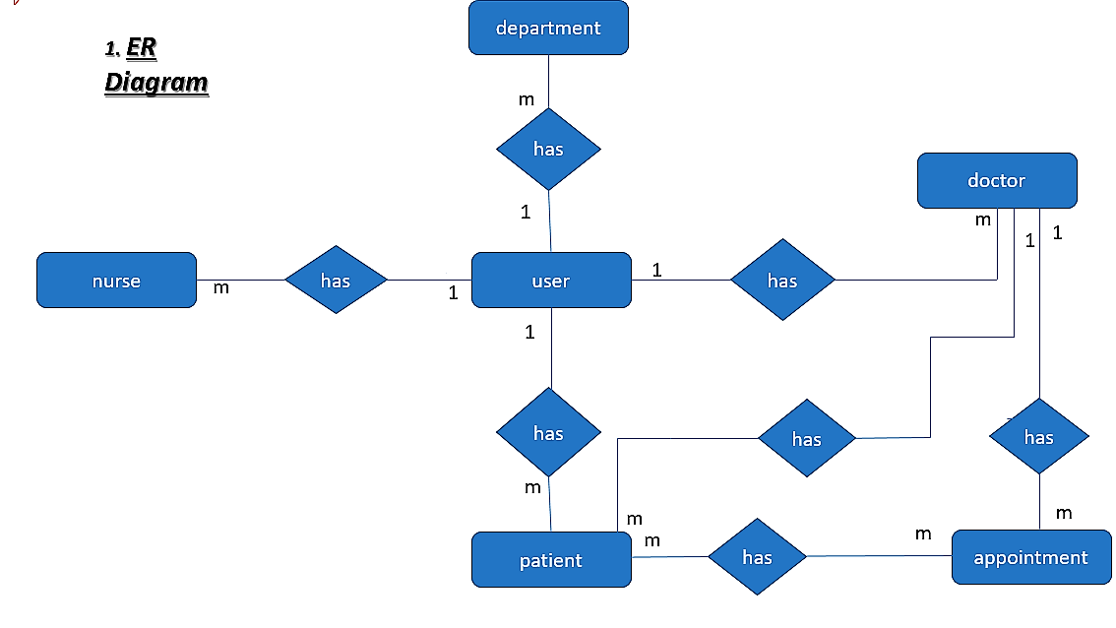

**Class Diagram:-**

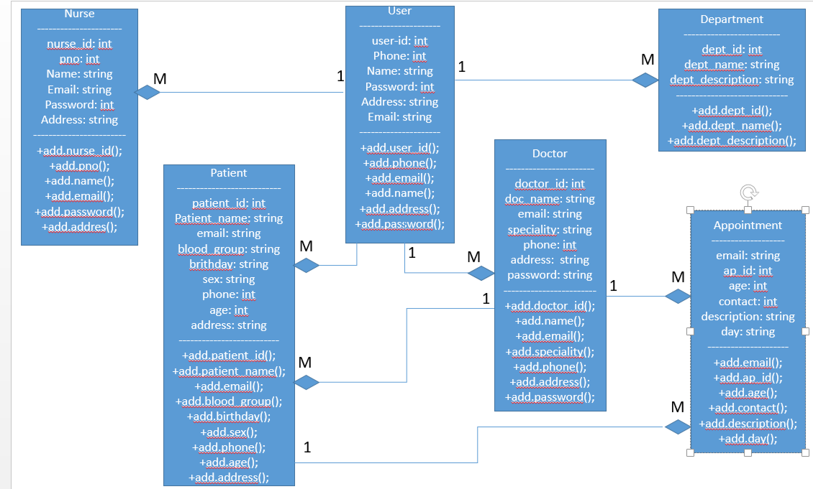

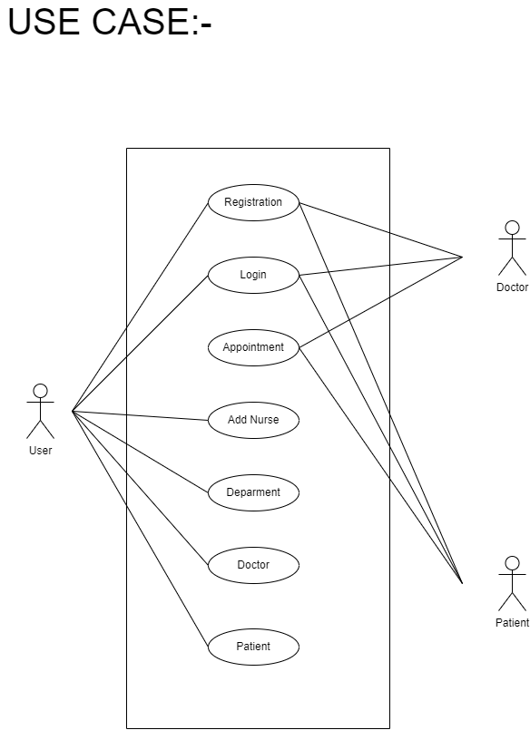

**Activity Diagram:-**

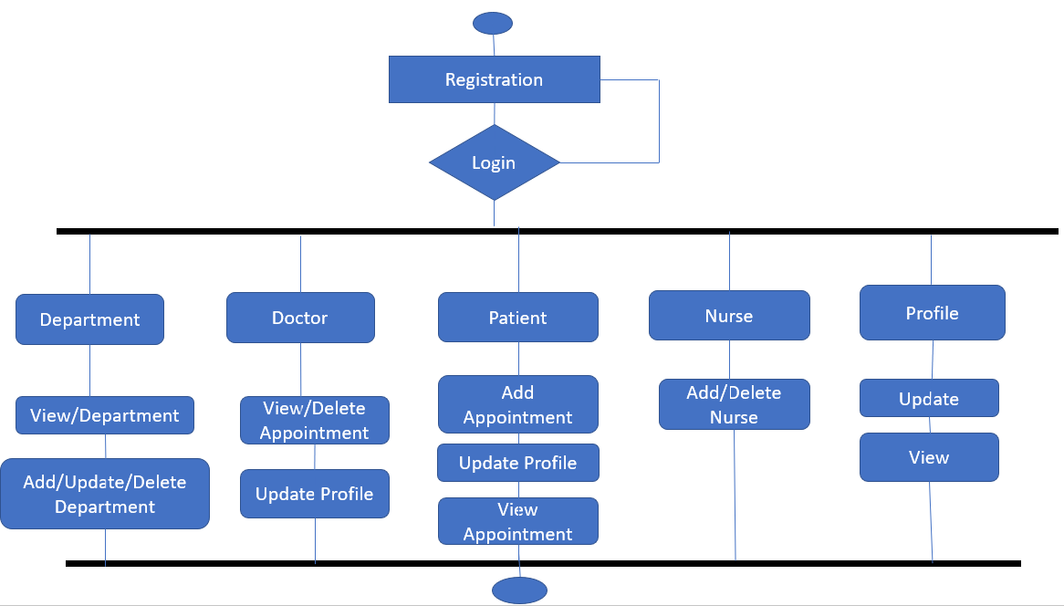

**Sequence Diagram:-**

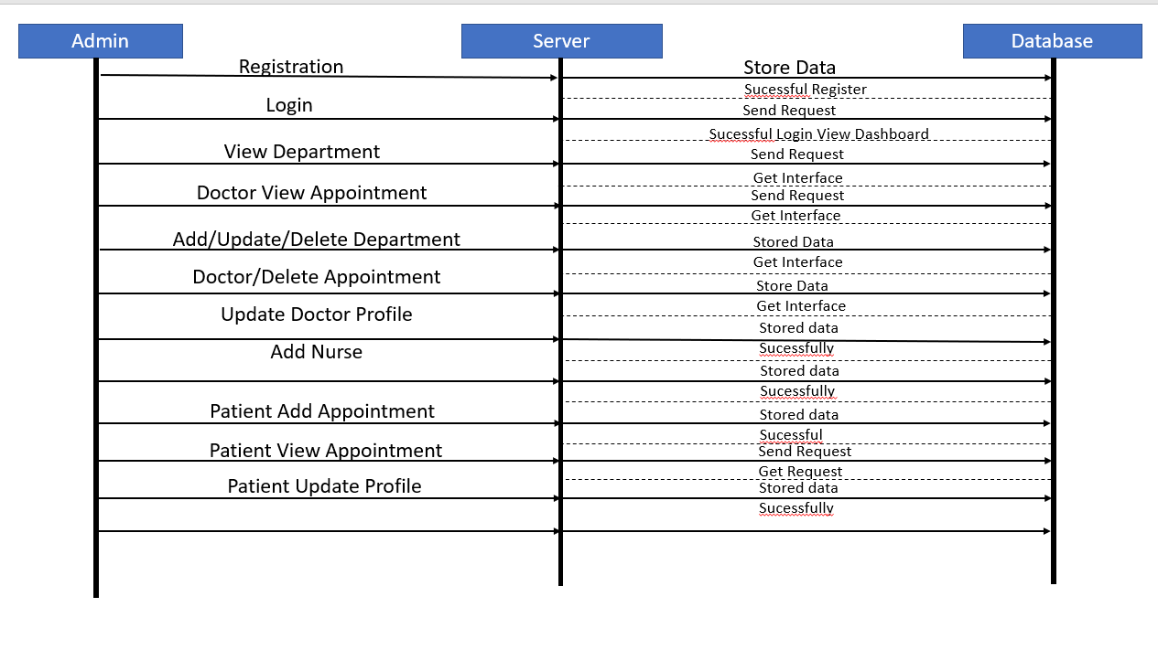

**State chart Diagram:-**

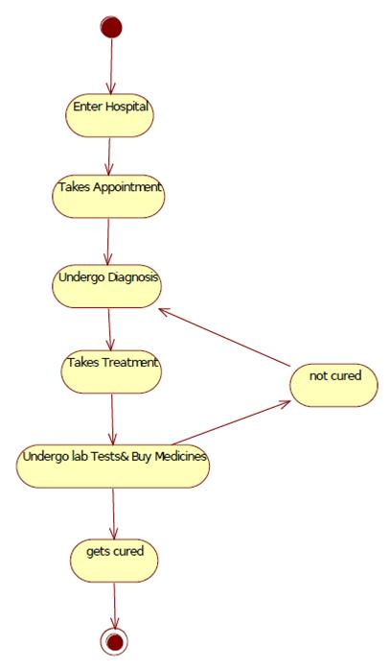

**Collabration Diagram:-**

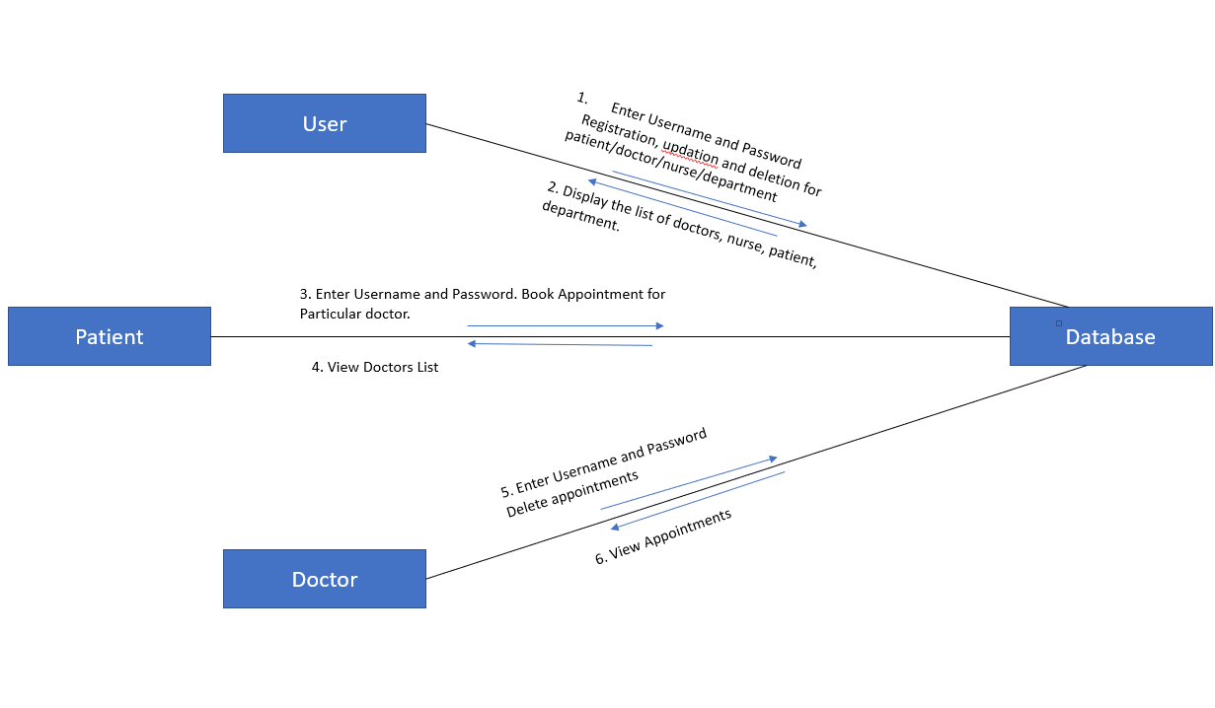

**Component Diagram:-**

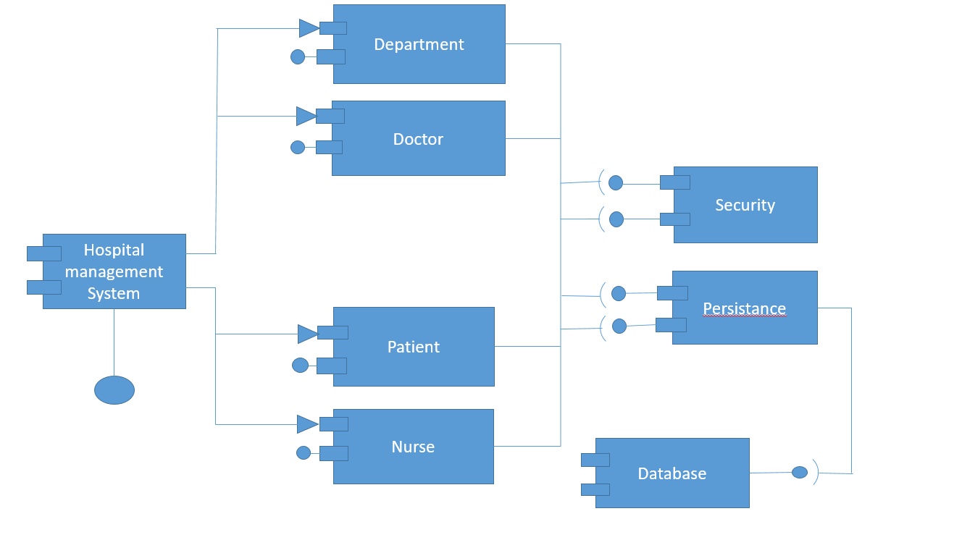

**Deployment Diagram:-**

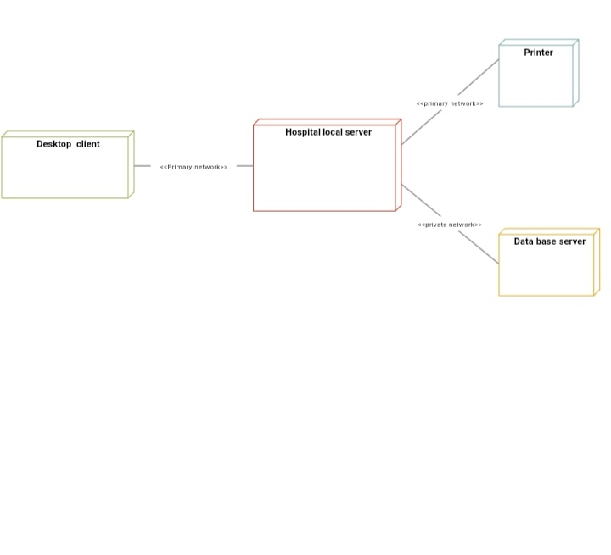



**Data Dictionary**

##### Data Dictionary

## appointment

|  |  |  |  |  |
| --- | --- | --- | --- | --- |
| Attribute Name | Data type | Size | Key | Description |
| ap_id | int(11) | 11 | PRIMARY KEY (Auto Increment) | Appointment id |
| name | varchar(50) | 50 | NOT NULL | Patient Name |
| email | varchar(130) | 130 | NOT NULL | Patient Email |
| contact | varchar(130) | 130 | NOT NULL | Patient Contact |
| age | int(11) | 11 | NOT NULL | Patient Age |
| day | varchar(130) | 130 | NOT NULL | Appointment  Day |
| speciality | varchar(130) | 130 | NOT NULL | Speciality |
| description | varchar(200) | 200 | NOT NULL | Description |
| id | int(11) | 11 | NOT NULL |  |

|  |  |  |  |  |
| --- | --- | --- | --- | --- |
| Attribute Name | Data type | Size | Key | Description |
| dept_id | int(11) | 11 | PRIMARY KEY (Auto Increment) | Department id |
| dept_name | varchar(100) | 100 | NOT NULL | Department name |
| dept_description | varchar(400) | 400 | NOT NULL | Department description |

* 1. **Department**

## Doctor

|  |  |  |  |  |
| --- | --- | --- | --- | --- |
| Attribute Name | Data type | Size | Key | Description |
| doctor_id | int(11) | 11 | PRIMARY KEY (Auto Increment) | Doctor id |
| doc_name | varchar(100) | 100 | NOT NULL | Doctor Name |
| email | varchar(100) | 100 | NOT NULL | Doctor Email |
| password | varchar(100) | 100 | NOT NULL | Doctor password |
| address | varchar(400) | 400 | NOT NULL | Doctor Address |
| phone | varchar(100) | 100 | NOT NULL | Doctor Phone |
| department | varchar(100) | 100 | NOT NULL | Doctor Department |

## Feedback

|  |  |  |  |  |
| --- | --- | --- | --- | --- |
| Attribute Name | Data type | Size | Key | Description |
| name | varchar(100) | 100 | NULL | Feedbacker’s Name |
| email | varchar(100) | 100 | NULL | Feedbacker’s email |
| contact | varchar(100) | 100 | NULL | Feedbacker’s contact |
| suggestion | varchar(400) | 400 | NULL | Feedbacker’s suggestion |

* 1. **nurse**

|  |  |  |  |  |
| --- | --- | --- | --- | --- |
| Attribute Name | Data type | Size | Key | Description |
| nurse_id | int(11) | 11 | PRIMARY KEY (Auto Increment) | Nurse id |
| name | varchar(45) | 100 | NOT NULL | Nurse name |
| email | varchar(100) | 400 | NOT NULL | Nurse Email |
| password | varchar(100) | 100 | NOT NULL | Password |
| address | varchar(400) | 400 | NOT NULL | Address |
| phone | varchar(100) | 100 | NOT NULL | Phone |

* 1. **Patient**

|  |  |  |  |  |
| --- | --- | --- | --- | --- |
| Attribute Name | Data type | Size | Key | Description |
| patient_id | int(11) | 11 | PRIMARY KEY (Auto Increment) | Patient id |
| patient_name | varchar(100) | 100 | NOT NULL | Patient Name |
| email | varchar(100) | 100 | NOT NULL | Patient Email |
| password | varchar(100) | 100 | NOT NULL | Password |
| address | varchar(400) | 400 | NULL | Patient Address |
| phone | varchar(100) | 100 | NOT NULL | Patient Phone |
| sex | varchar(45) | 45 | NULL | Patient Sex |
| birthdate | varchar(100) | 100 | NULL | Birthdate |
| age | int(11) | 11 | NULL | Age |
| blood_group | varchar(45) | 45 | NULL | Blood Group |

|  |  |  |  |  |
| --- | --- | --- | --- | --- |
| Attribute Name | Data type and size | size | Constraints | Description |
| user_id | int(11) | 11 | PRIMARY KEY (Auto Increment) | User Id |
| name | varchar(100) | 100 | NOT NULL | User Name |
| email | varchar(100) | 100 | NOT NULL | User Email |
| address | varchar(400) | 400 | NOT NULL | User Address |
| phone | varchar(200) | 200 | NOT NULL | User Phone |
| password | varchar(100) | 100 | NOT NULL | User Password |

* 1. **User**



**Screen Shots**

##### Screen Shots

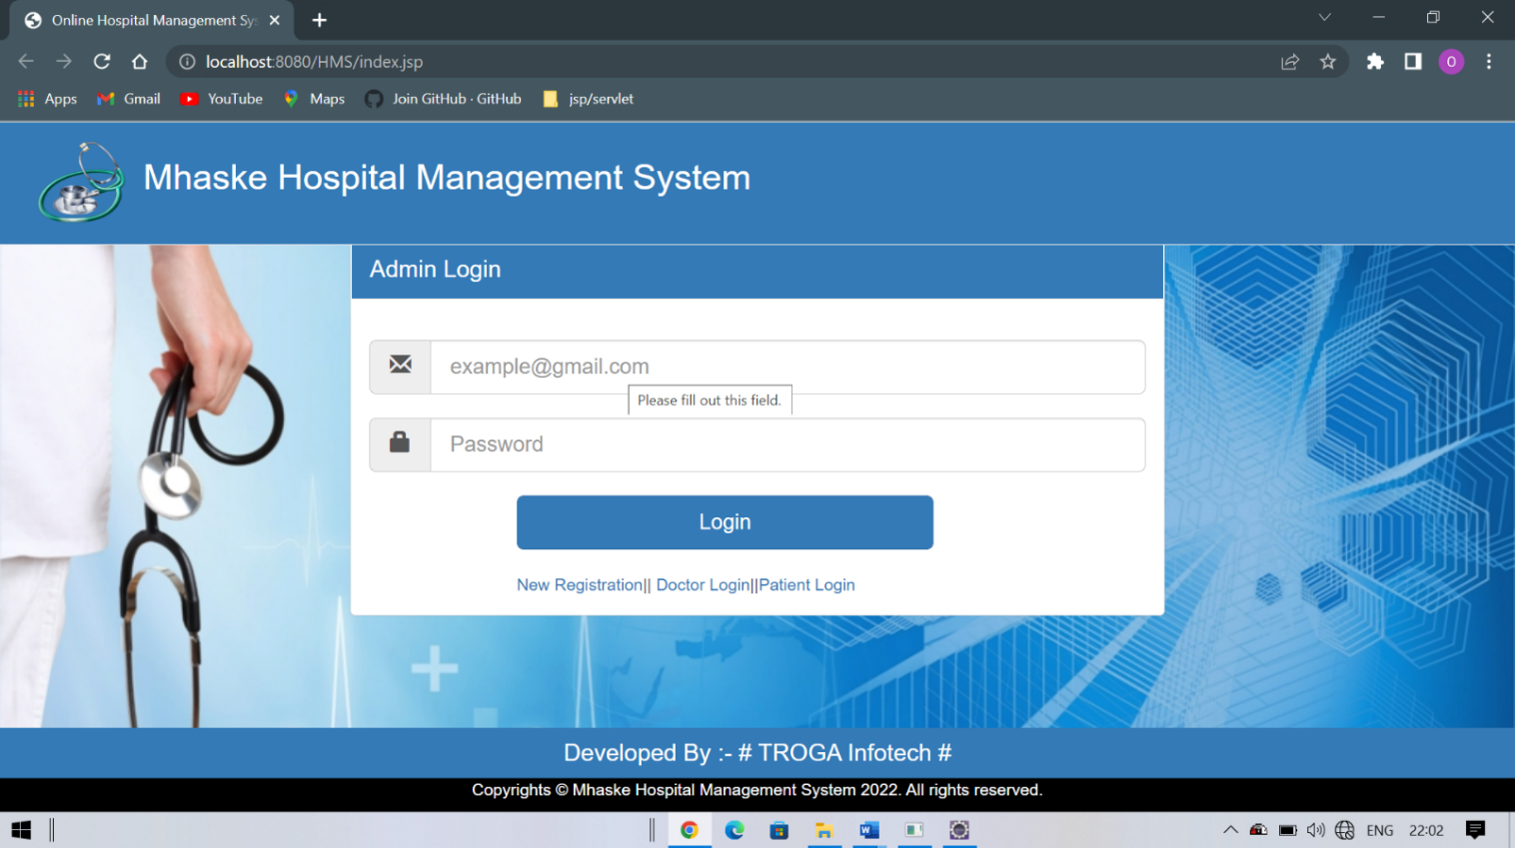1.Admin

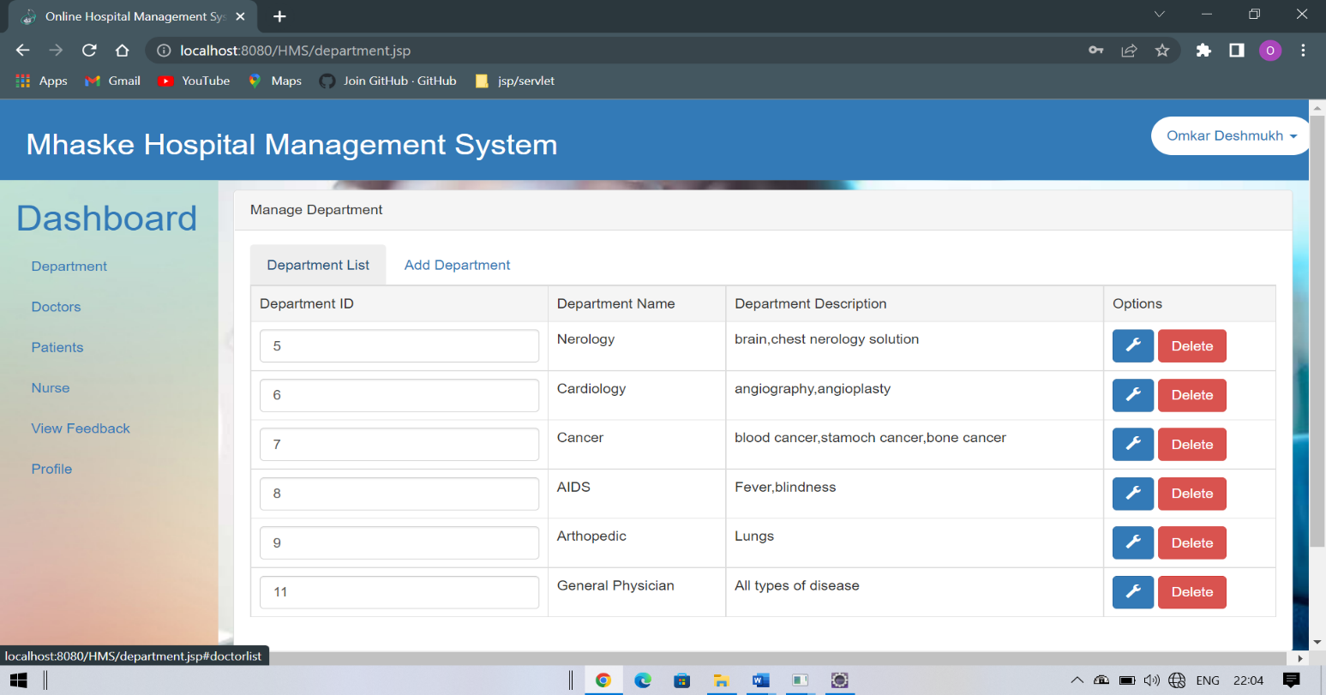2. Admin Homepage

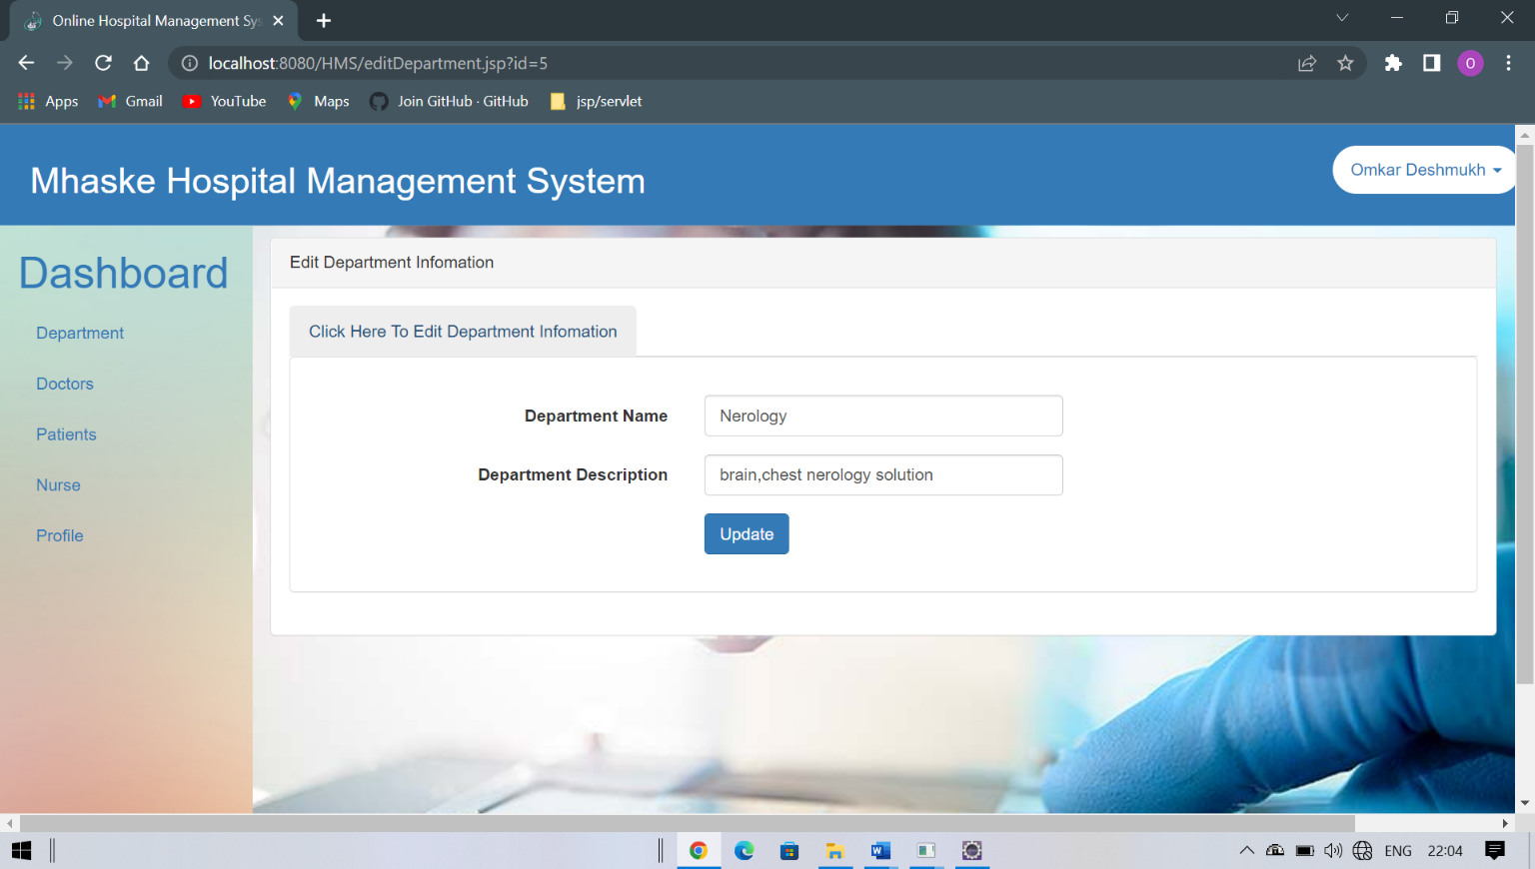3. Edit Department

4. Add Department

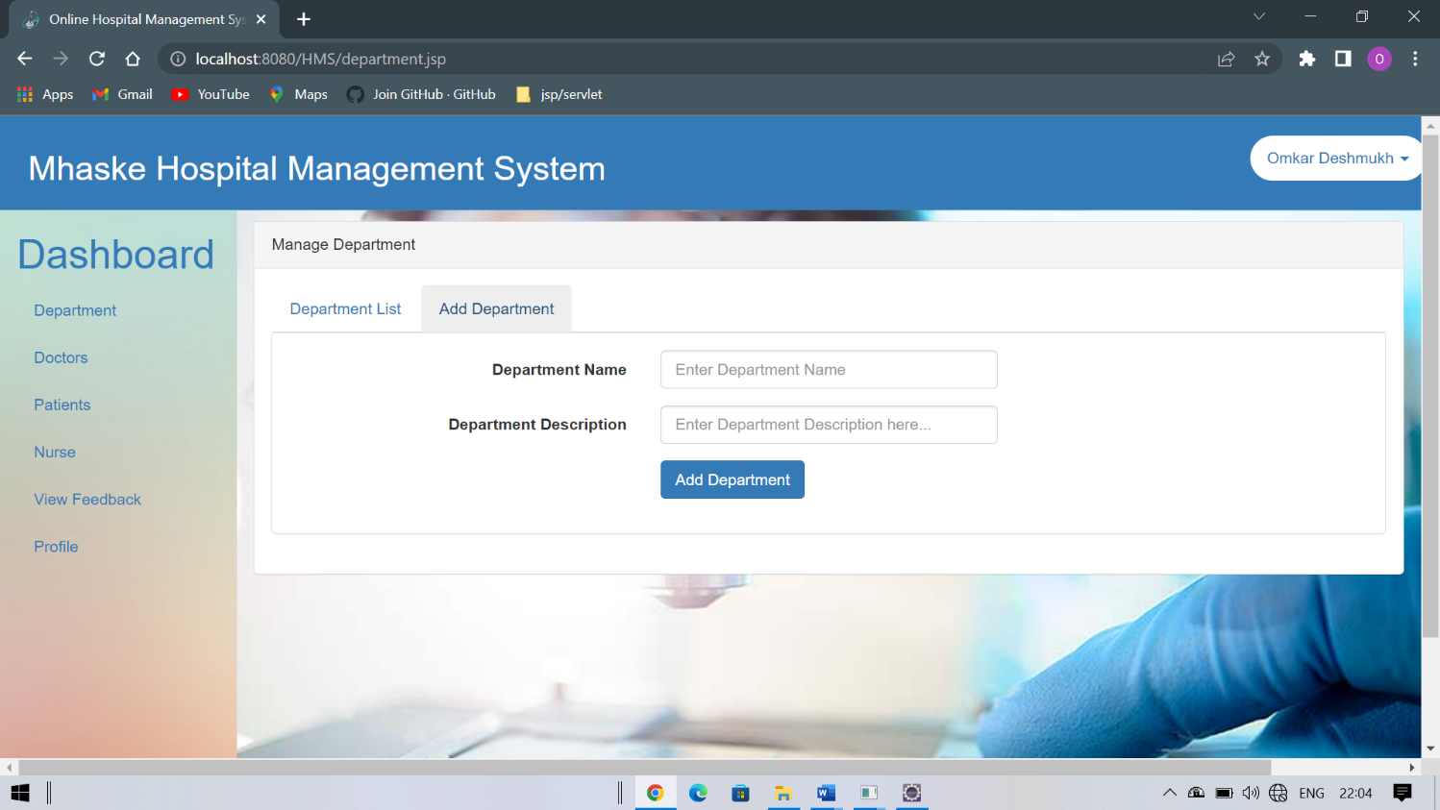

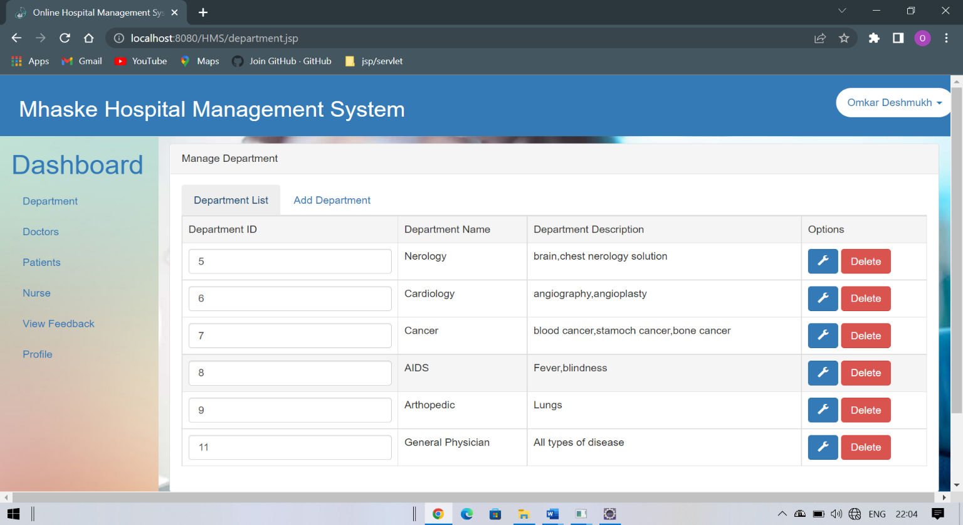5. All Department

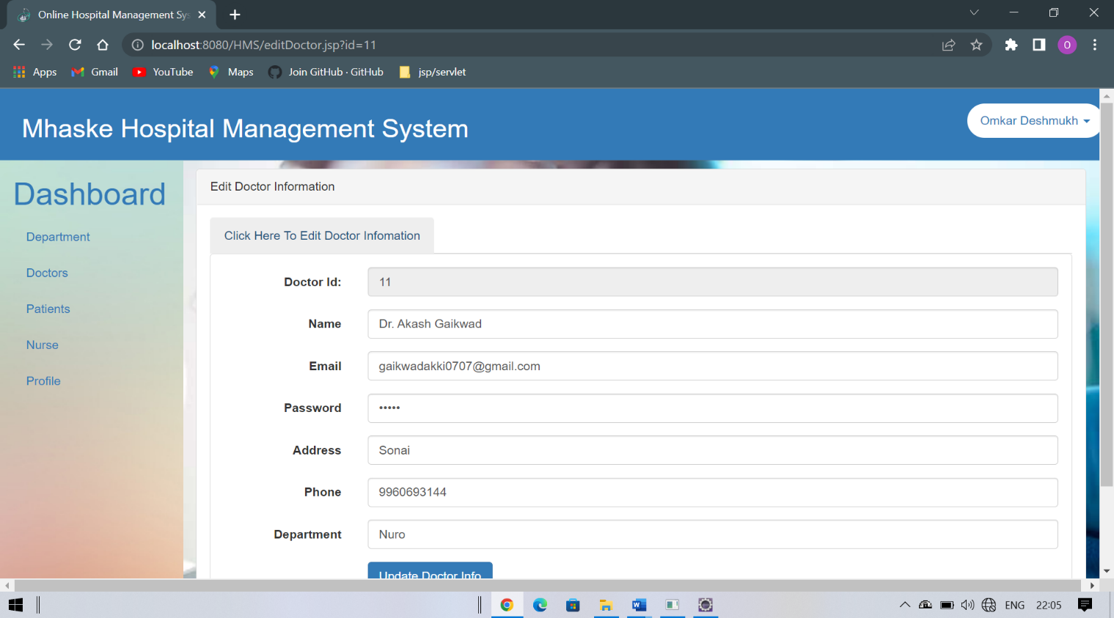6. Update Doctor

7. Add New Doctor

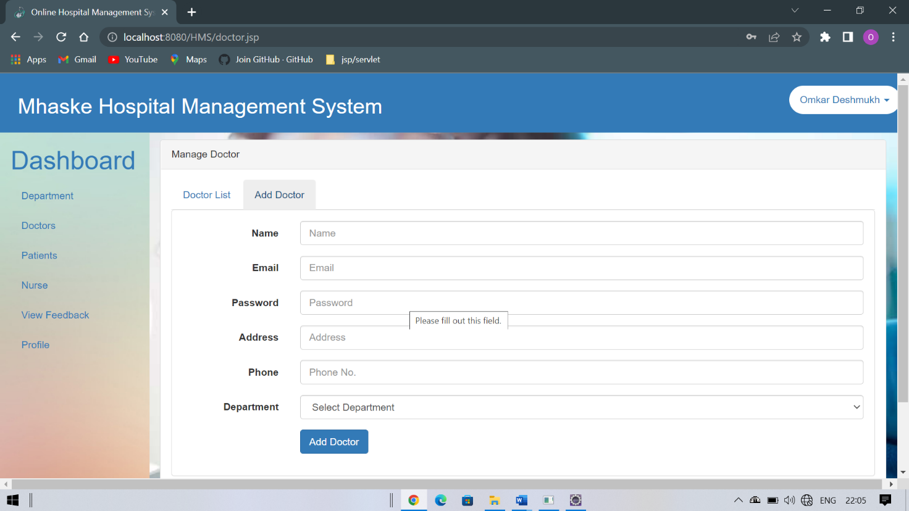

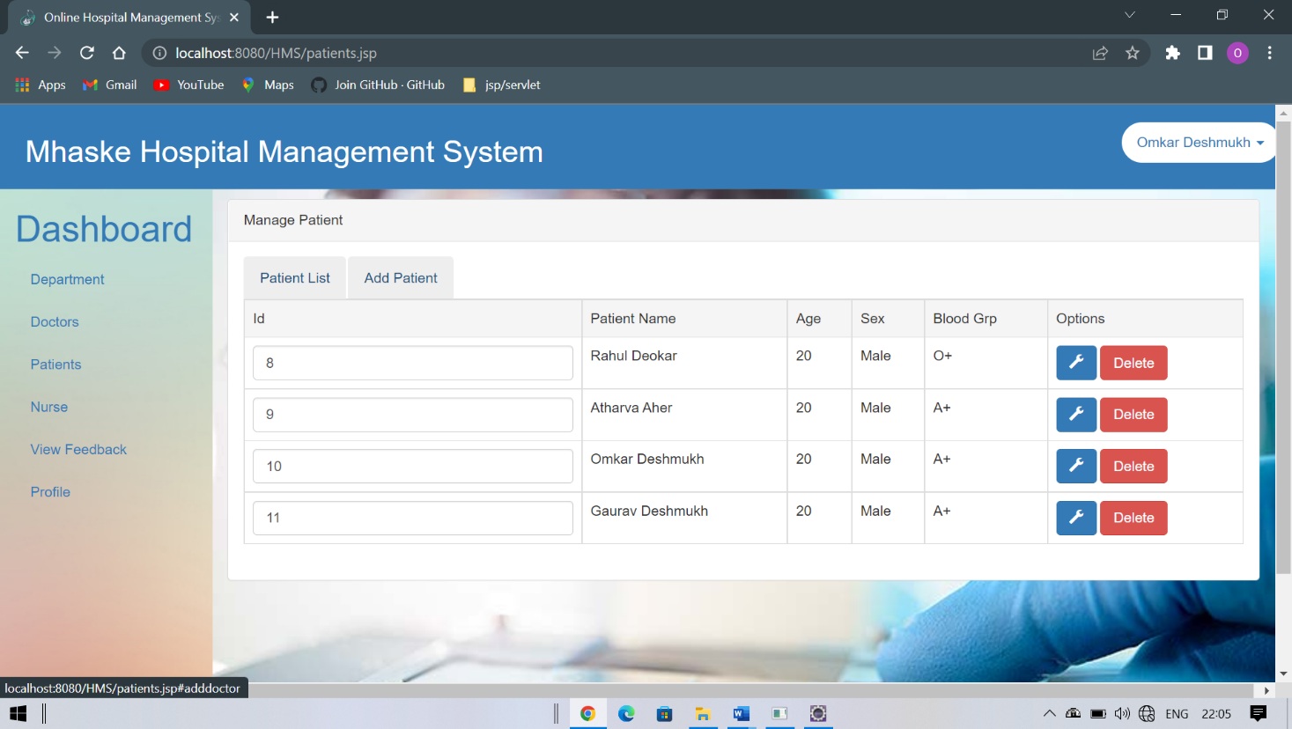8. Patient List

9. Add New Patient

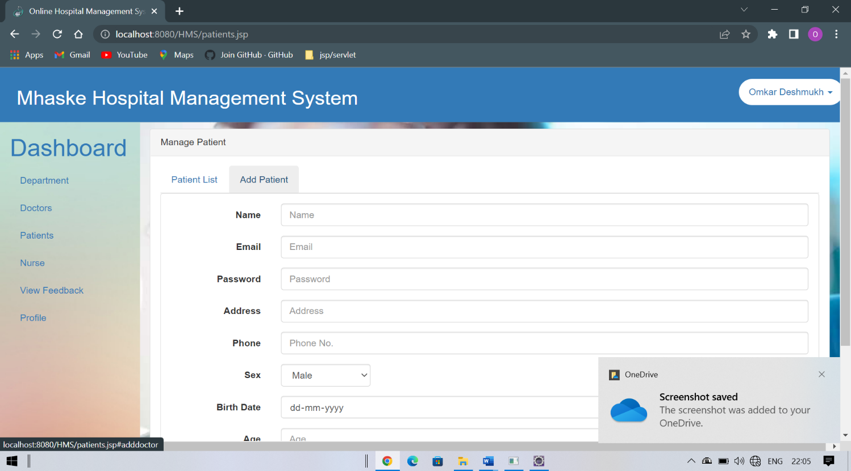

10. Feedback Details

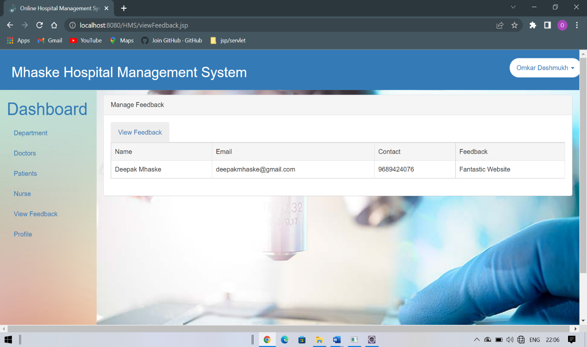

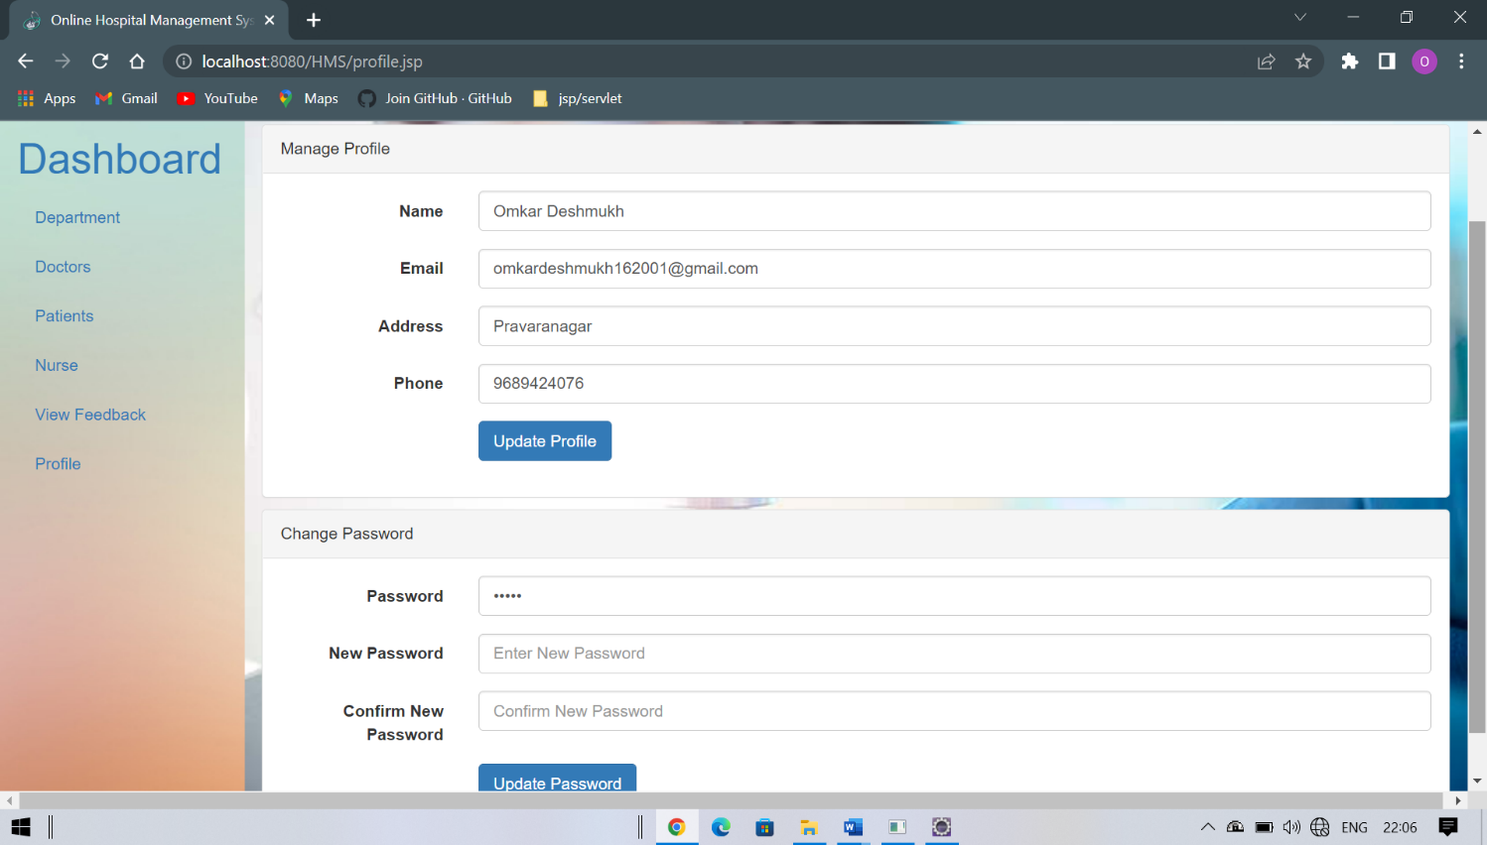11. Profile Updation/User Updation

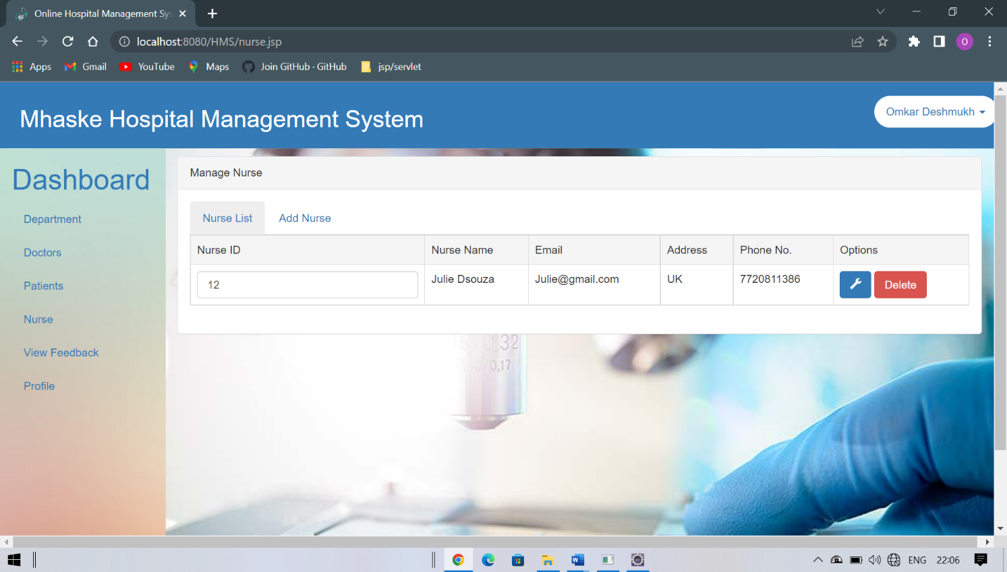12. All Nurse Details

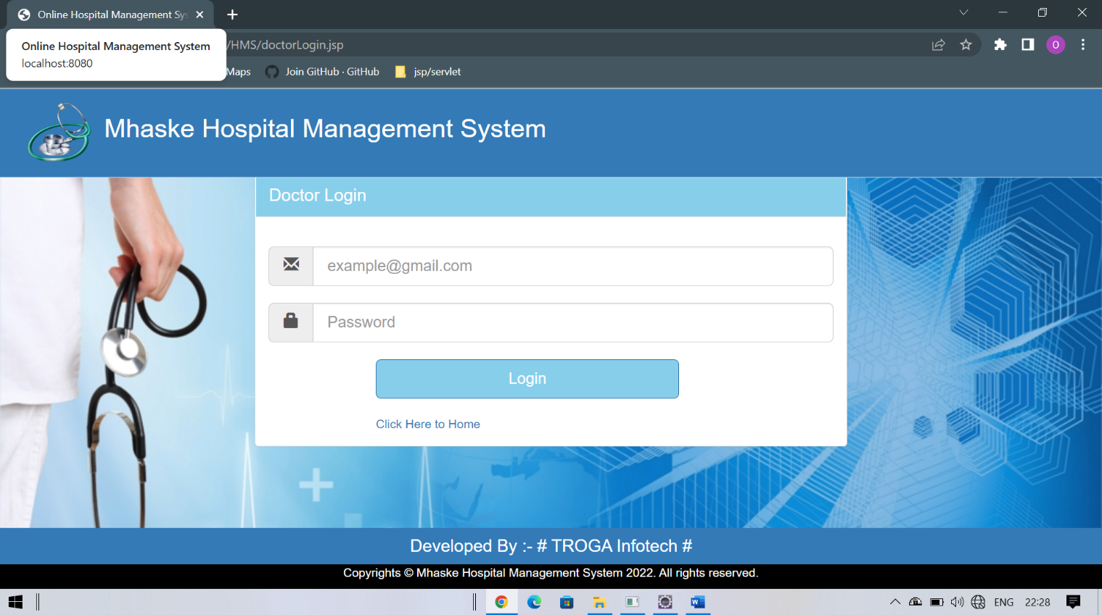13. Doctor Login

14. Doctor Profile Updation

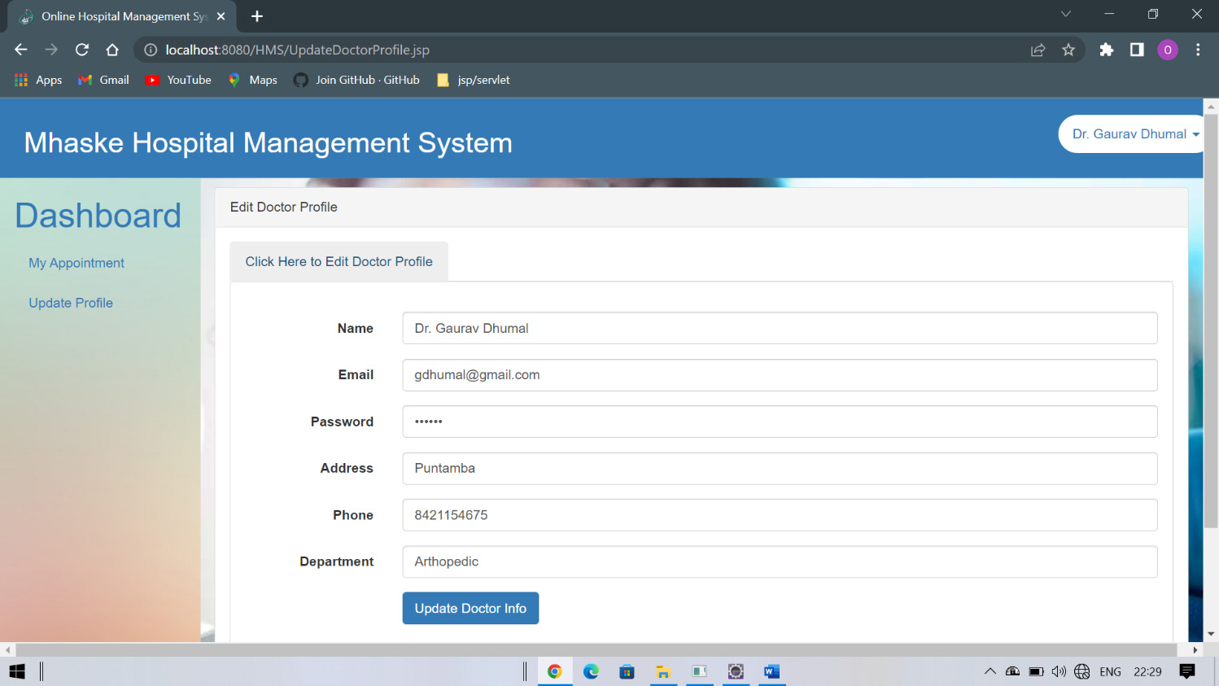

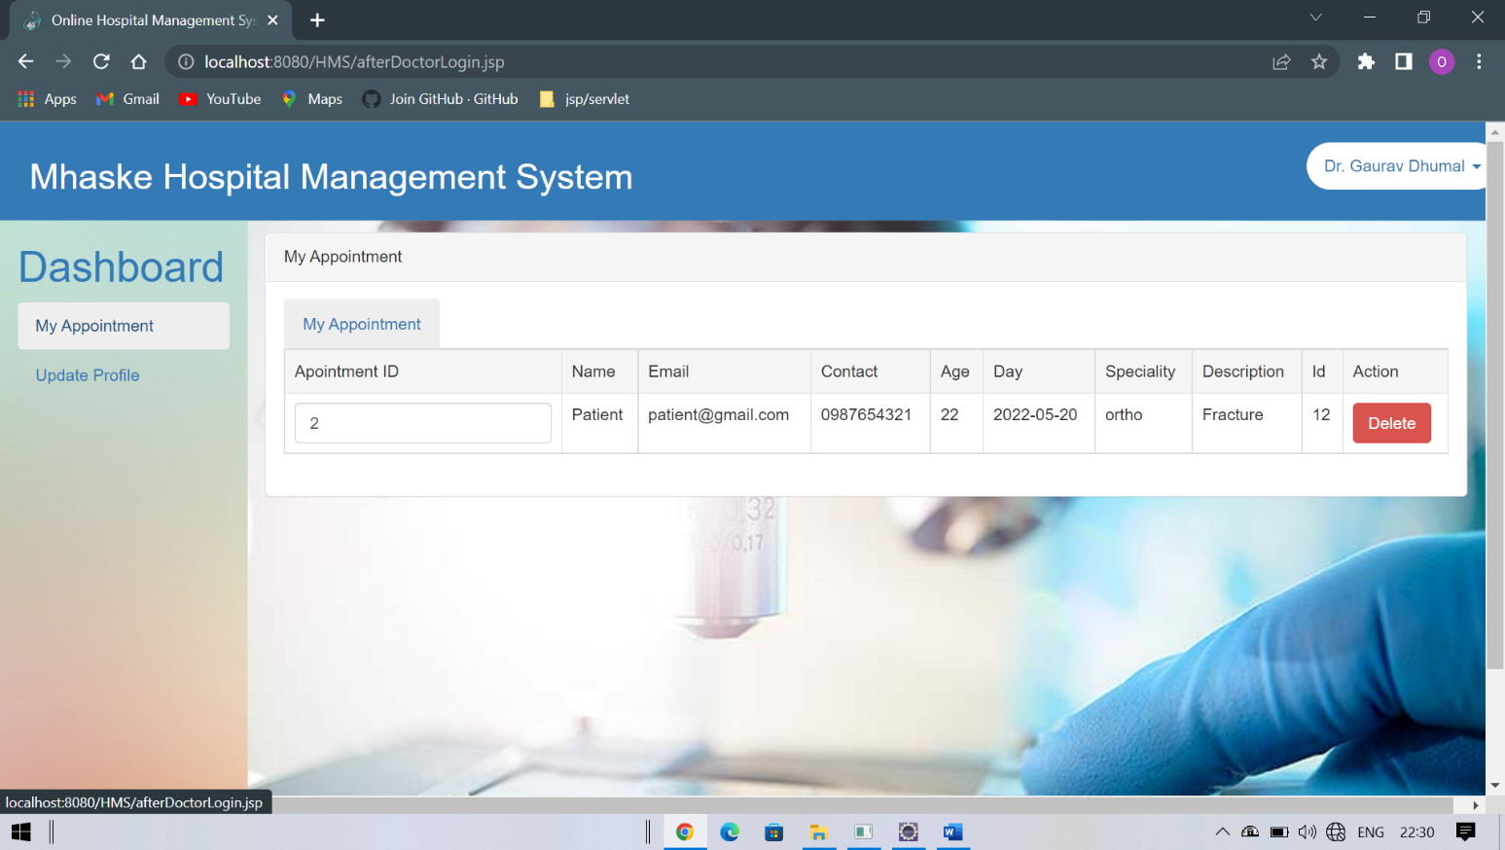 15. Appointment List in Doctors Login

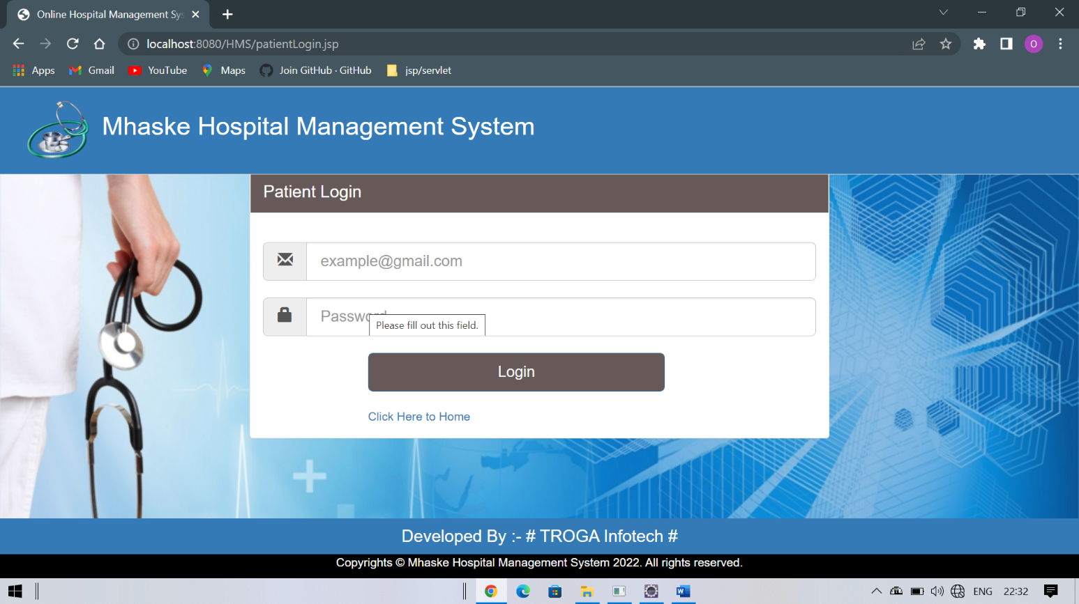 16. Patient Login

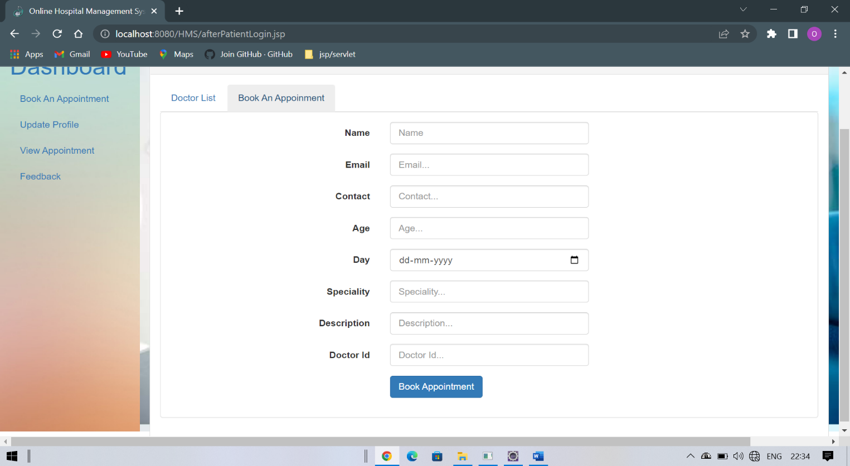17. Book An Appointment

18. View Appointment

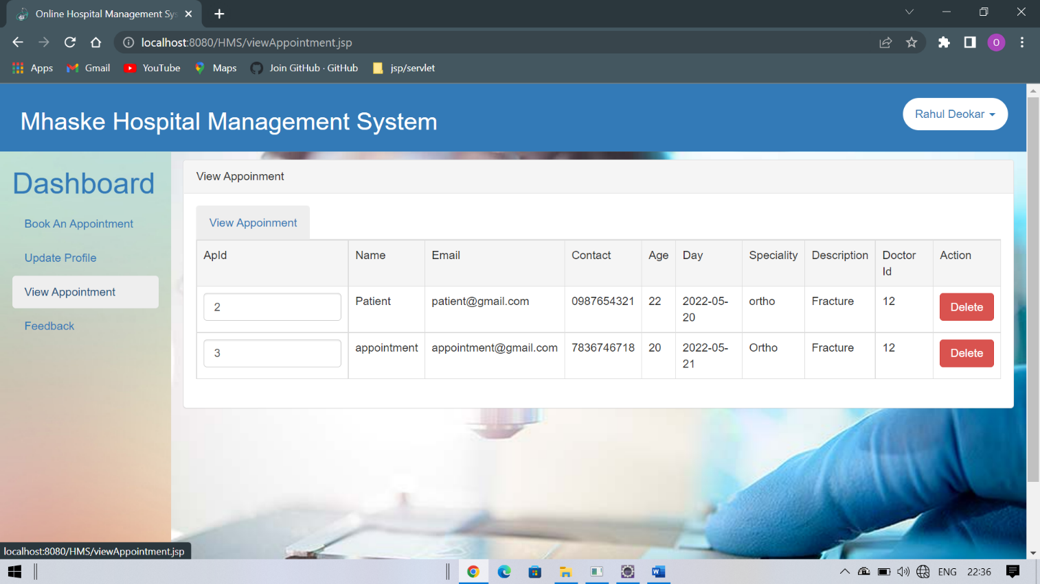



**Proposed System Enhancement**

##### 6.1 Proposed System Enhancement

The Proposed System is hospital management system. We can enhance this System by including more facilities like binding system, in patient room allotment for the admitted patients and the stock details of medicines in the pharmacy. Providing such features enable the users to include more comments into the system.

1. We Can add Printer in future.
2. We can give more advance software for hospital management system including more facilities.

3.we will host the platform on online servers to make it accessible worldwide

4. Integrate multiple load balancer to distribute the loads of the system.

1. Create the master and slave database structure to reduce the overload of the database queries.
2. Implement the backup mechanism for taking backup of codebase and database on regular basis on different servers.

The above mentioned points are the enhancements which can be done to increase the applicability and usages of this projects. Here we can maintain the records of Hospital and Doctors. Also as it can be seen that now–a-days the players are versatile, i.e. so there is a scope for introducing a method to maintain the hospital management system. Enhancement can be done to maintain all the Hospital, Doctors, Patient, Employee, Test.



**Conclusion**

##### Conclusion

The Online Hospital management System is the great improvement over the manual System using the case fields and paper .The computerization of the system has sped up the process in the current system ,the front office managing is very Slow The hospital managing system was throughtly checked and tested with dummy data and thus is found to be very reliable

Our project is only a humble venture to satisfy the needs to manage their project work. Several user friendly coding have also adopted .this package shall prove to be a powerful package in satisfying all the requirements of the school. The objective of software planning is to provide a frame work that enables the manager to make reasonable estimates made within a limited time frame at the beginning of the software project and should be updated regularly as the project progresses.

At the end it is concluded that we have made effort on following points.

* A description of the background and context of the project and its relation to work already done in the area.
* Made statement of the aims and objectives of the project.
* The description of Purpose, Scope, and applicability.
* We define the problem on which we are working in the project.
* We describe the requirement specification of the system and the actions that can be done on these things.
* We understand the problem domain and produce a model of the system, which describes operations that can be performed on the system.
* We included features and operations in detail, including screen layouts.
* We designed user interface and security issues related to system.
* Finally the system is implemented and tested according to test cases.



**Bibliography**

##### 8.1 Bibliography

Before, during and after the development of the computerized system we refer some books which guide me for program development, coding, drawing graphic representation etc. List of such books is specified below:

# Reference books:-

* Java- the complete reference

# Websites:-

* **https://www.javatpoint.com/**
* **https://stackoverflow.com/**
* [**https://turialpoint.com**](https://turialpoint.com)